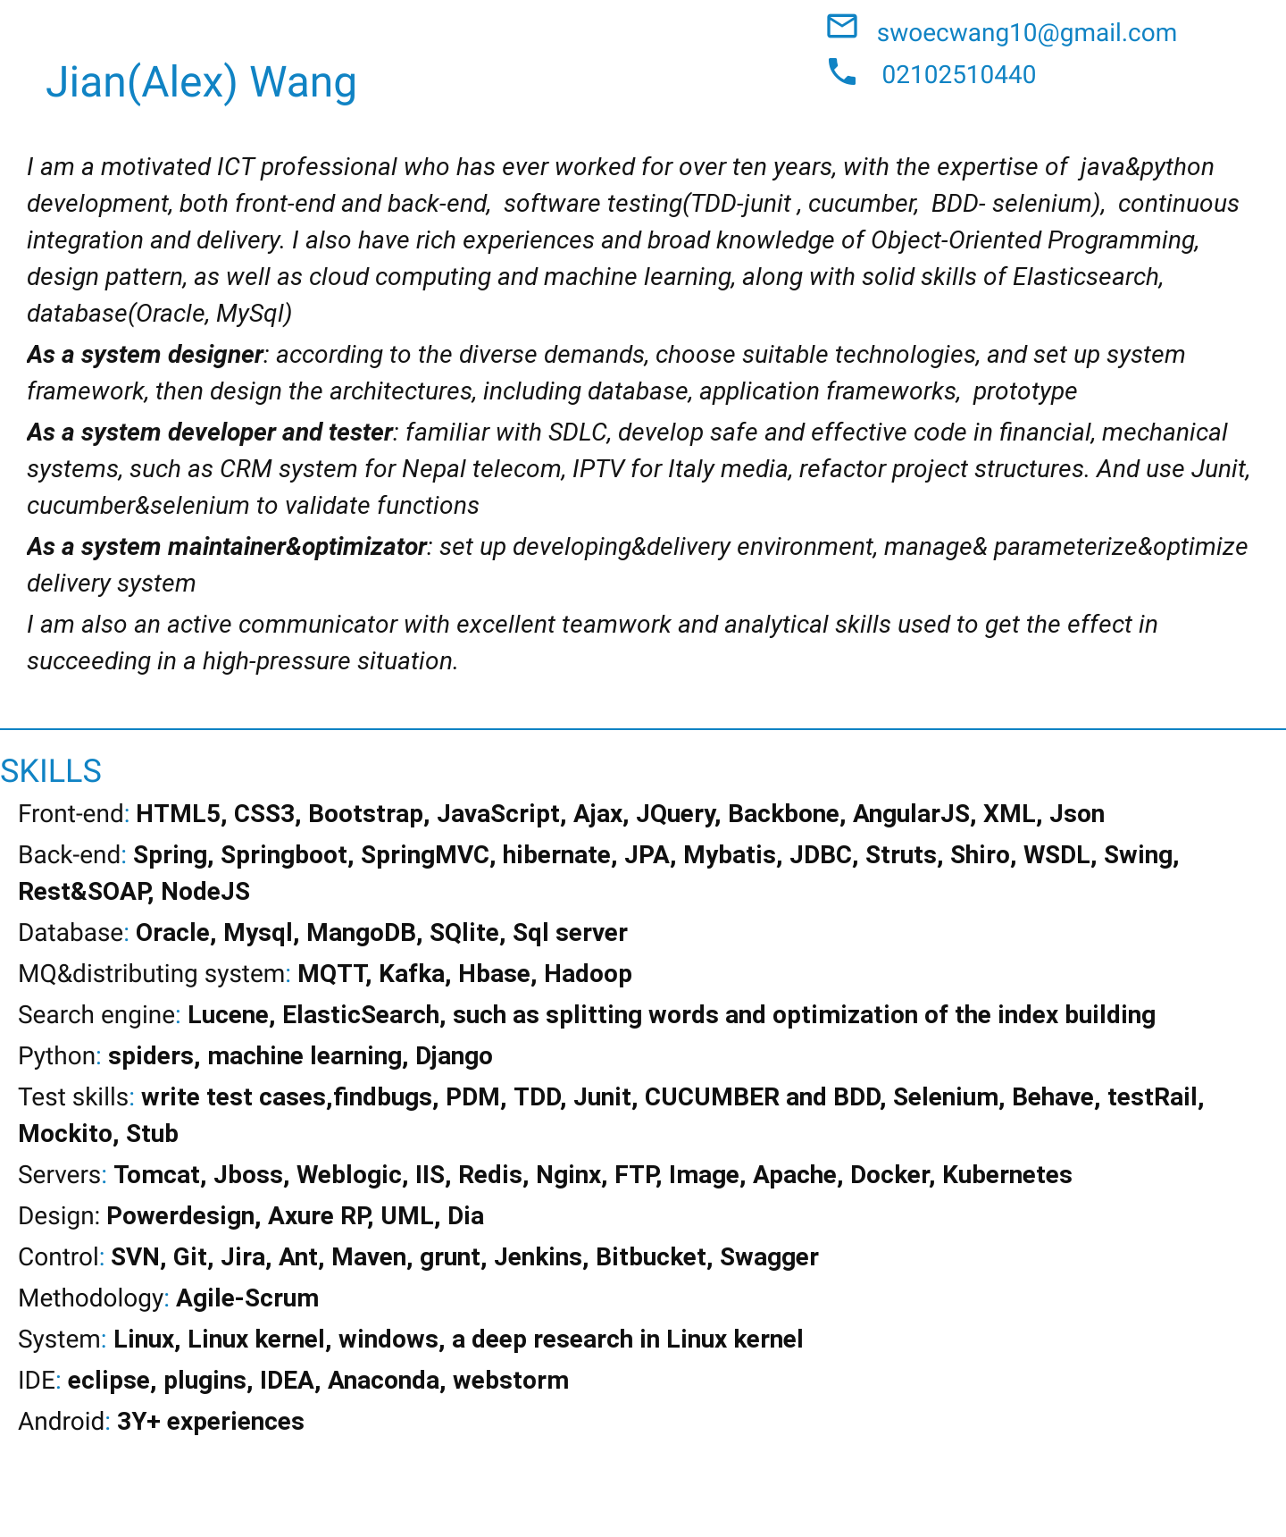

*LinkedIn:*[*https://www.linkedin.com/in/alex-wang-63237b39/*](https://www.linkedin.com/in/alex-wang-63237b39/)

*Github:*[*https://github.com/swoec*](https://github.com/swoec)

***PROFESSIONAL EXPERIENCE***

***Software developer XM developments 08/2018– Auckland***

*XM developments is a company working on e-commerce system and online stores*

*The e-commerce platform is based on Java8, Jpa, spring-boot, Elasticsearch, Redis, test using behave, cucumber, Junit, Testrail, Git, Bitbucket, as well as Docker, Kubernetes.*

-> Added new features to user groups: add new columns to the database(flyaway), upgrade models, and relative functions. Write the test case and test the new features(behave in python and Junit)

-> Labels setting block: designed the label setting tables, designed the Rest APIs, developed all the functions(service, JPA, flyway), function test(behave in python), JUnit test

-> Junit test and Functional test

-> Designed database

-> Designed Rest APIs

-> Code Review

-> Code refactoring

* *complete all the functions and Rest APIs, add new features added to the system*

***Team Leader &architect senior engineer Ligoo New Resource Co, LTD 02/2016-03/2018 Hefei***

*Ligoo New Resource is the second largest company building BMS for the electric vehicle as well as diverse services in China.*

-> Designed web Framework(Spring framework)

-> Developed upgrade system by using message queue(MQTT)

-> Maintained the platform and delivery servers(Ubuntu)

-> Analysis the data by using python

-> Designed and built the development environment and architecture  
-> Implemented core business services  
-> Leaded the development of the online platform  
-> Code review  
-> Designed and developed components(Front-end & Back-end)  
-> Addressed and fixed bugs  
-> Cooperated with test&operation engineers to optimize business services

-> Developed an Android APP for a logistics system

-> Developed a search engine by using Elasticsearch

-> Developed a pipeline by using Kafka

-> Developed spiders to grab data from Internet with Python

-> Junit Test, Functional Test, Driving Test

-> Requirements analysis

* **Project: Real-time logistics and billing system**  Platform: Android
* Downloaded the bills from the server, and displayed the details of retail bills in the pad, when our Customers check in to the pad with ID card, system uploads the information to the server automatically When the GPRS or Wifi is available, otherwise storing the records in SQLite database The evaluation also can be implemented in the system by customers.
* Connected to the call system and sent short messages before their goods arrived.
* Plan the road which can save money, Monitor the vehicle speed and status
* Driving test for the system, customize and maintain the delivery environment
* Save 15% fares on gasoline every year Transportation rates 20% higher Save time for the users

Delivery service improved An annual award from the headquarters

* *Saved a lot of money(at least 2 M dollars every year) to maintain numerous users and respond quickly to users complaints.*
* *Won more attention and users as the system can help our customers to monitor their vehicles' status and get the vehicle’s situation even details, as well as to know the warnings and potential risks*
* *Successful to support 30 times growth a years.*

***Senior Software engineer Aisainfo-inc Global Delivery Service 06/2014—01/2016*****Nanjing**

*one of largest CRM software supplier in the world (NASDAQ: ASIA)*

-> Developed functions for Nepal Telecoms, such as balance system, booking system, clients Package system

(Front-end & Back-end)

-> Clarified meta-data and optimized the system structure(Oracle)

-> Developed plug-ins

-> Reacted with web interfaces

-> Fixed bugs and maintained the system

-> Developed workflows

-> Junit Test

* *Support diverse demands from the users*

*Continuous integration and delivery when whatever happens(even a big earthquake)*

***Senior Software engineer CITIC Department of venture Control 06/2012-06/2014* Nanjing**

*CITIC corp is the largest financial company in China and top 500 companies in the world.*

-> Designed customized blocks

-> Developed features for Audit platform(Front-end & Back-end)

-> Data transfering

-> Junit and functional test

-> Integration Test and Delivery

-> Developed APPs for Bank in Android

* **Project: Queue System in Bank** Platform：Android
* Developed functions in the native model by using SQLite,socket server: such as:

To Display the customer’s information

To Classify the customers

To Assign a queue number for each customer

VIP service: with RFID, the system can identify our VIP customers when they enter the hall and display their information in the manager’s pad automatically, the manager assigns them to VIP rooms so the VIPs do not need to wait in the queue. The manager also can recommend special financial products to them based on their user portraits from their information analysis

* *Improve the service quality 200% Better resource relocation*

*Saving money as more as 20 thousand dollars every year for every branch(more than 500 branches)*

***Architect Compal R&D center 06/2010-2012*****Nanjing**

*The second-largest contract laptop manufacturer in the world, also top 500 companies in the world, headquarters is in Taipei, Taiwan, with offices in the People's Republic of China, South Korea, the United Kingdom and the United States*

-> Refactored our Android systems

-> Designed system structure

-> Developed new features

-> Interacted with external web interfaces

-> Designed and Developed web interfaces

-> Developed a search engine(Lucene)

* **Project: Unitilies tools**  Platform：Android
* Refactor our android system to make it more smart and flexible. Developing new functions in the native model
* *Codes became the assets*

***Senior. Software Engineer ZTE 06/2008-05/2010*** **Nanjing**

*The fourth Largest mobile equipment manufacturer in the world, with offices in 180 countries.*

-> Mainly developed fac&fas, using multi-thread, and IPC, message-queue, pre-read for cloud storage system

-> Tested and analyzed the bugs

-> Optimized the system

-> Wrote reports to compare our product with several other cloud products

* *Sold billions of US dollars every year*
* *Supplies services for Italy telecom, Vietnam telecom, China Telecom, and many other countries.*

***Software Engineer Inspur 06/2006-06/2008*****Nanjing**

*one of the largest solution provider in the world*

-> Developed the core block for SIP(Java Web project)

-> Designed and Developed new layers for map(Java Swing)

-> Developed super-large search trees(more than 100,000 points)

-> Developed themes and search functions by using swing

-> Junit and Functional test

-> Code review

-> Fixed bugs

* *12600 times faster by using multithread to get massive data*

**Education**

*Computer Science Shandong University 2002 IBM DB2 International Certified (2006)*

**References**

REFERENCES ARE AVAILABLE ON REQUEST